**Experiment No:06**

**Experiment Name:** First-Come-First-Served (FCFS) Scheduling Algorithm Implementation.

**Aim and Objectives:** To Learn what is FCFS algorithm and how it work.

**First-Come-First-Served (FCFS) Scheduling Algorithm**

First-Come-First-Served algorithm is the simplest scheduling algorithm is the simplest scheduling algorithm. Processes are dispatched according to their arrival time on the ready queue. Being a non-preemptive discipline, once a process has a CPU, it runs to completion.

**Algorithm:**

* Start the process
* Declare the array size
* Get the number of processes to be inserted
* Get the value
* Start with the first process from it’s initial position let other process to be in queue
* Calculate the total number of burst time
* Display the values
* Stop the process

**Source Code:**

#include<stdio.h>

void main()

{

int n,a[10],b[10],t[10],w[10],g[10],i,m;

float att=0,awt=0;

for(i=0; i<10; i++)

{

a[i]=0;

b[i]=0;

w[i]=0;

g[i]=0;

}

printf("enter the number of process:");

scanf("%d",&n);

printf("enter the burst times:");

for(i=0; i<n; i++)

scanf("%d",&b[i]);

printf("\nenter the arrival times:");

for(i=0; i<n; i++)

scanf("%d",&a[i]);

g[0]=0;

for(i=0; i<10; i++)

g[i+1]=g[i]+b[i];

for(i=0; i<n; i++)

{

w[i]=g[i]-a[i];

t[i]=g[i+1]-a[i];

awt=awt+w[i];

att=att+t[i];

}

awt =awt/n;

att=att/n;

printf("\n\tprocess\twaiting time\tturn arround time\n");

for(i=0; i<n; i++)

{

printf("\tp%d\t\t%d\t\t%d\n",i,w[i],t[i]);

}

printf("the average waiting time is %f\n",awt);

printf("the average turn around time is %f\n",att);

}

**Output:**

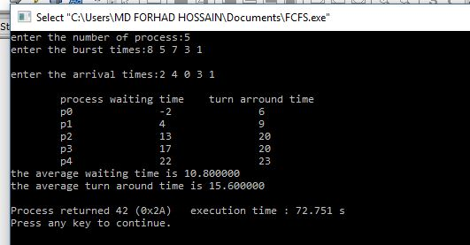

**Conclusion:**

After doing this labreport we learn about First-Come-First-Served (FCFS) scheduling algorithm. We also learn how to implement First-Come-First-Served (FCFS) scheduling algorithm by using C program And testing the program different input and find output.